

Navio: ev trip planner platform
(Thailand focused)

mr. suriya upariphutthiphong
mr. prapangkorn thangsathityangkul
mr. supakrit duangsri

A SENIOR PROJECT SUBMITTED IN PARTIAL FULFILLMENT
OF THE REQUIREMENTS FOR THE DEGREE OF
BACHELOR OF SCIENCE
(COMPUTER SCIENCE)
SCHOOL OF INFORMATION TECHNOLOGY
KING MONGKUT'S UNIVERSITY OF TECHNOLOGY THONBURI
2026

Navio: EV Trip Planner Platform
(Thailand Focused)

Mr. Suriya Upariphutthiphong 66130500858
Mr. Prapangkorn Thagsathityangkul 66130500848
Mr. Supakrit Duangsri 66130500856

B.Sc. (Computer Science)
A Senior Project Submitted in Partial Fulfillment
of the Requirements for the Degree of
Bachelor of Science (Computer Science)
School of Information Technology
King Mongkut's University of Technology Thonburi
2026

Project Committee

………………………………………………. Member and Project Advisor
(Aj. Ekapong Jungcharoensukying)

………………………………………………. Member
(Asst. Prof. Dr. Chakarida Nukoolkit, Ph.D.)

………………………………………………. Member
(Assoc. Prof. Dr. Jonathan Hoyin Chan, Ph.D.)

………………………………………………. Member
(Assoc. Prof. Dr. Vajirasak Vanijja, Ph.D.)

………………………………………………. Member
(Dr. Vithida Chongsuphajaisiddhi, Ph.D.)

Copyright reserved
Thesis Title Preparation and Enaluation of Black Chrome Selectives on Low Carbon Steel and Aluminu Substrate
Thesis Credits 12
Candidate Miss Nandh Thavarungkul
Thesis Advisors Asst. Prof. Dr. Thumrongrat Amornraksa
Asst. Prof. Dr. Name Sername
Program Master of Engineering
Field of Study Computer Engineering
Department Computer Engineering
Faculty Engineering
Academic Year 2015

Abstract

[data]
[data]
Keywords : [Such as Aluminium Surface / Black Chrome (Selective Surface) / [Such as Aluminium Surface

ACKNOWLEDGEMENTS

[Text]
[Text]

ไม่ต้องลงท้ายชื่อผู้เขียน

Contents

CHAPTER 1 INTRODUCTION 1
1.1 Background Information 1
1.2 Objectives 2
1.3 Scope 2
1.4 Expected Benefits 3
Chapter 2 Feasibility Study 4
2.1 Introduction 4
2.2 Problem Statement 4
2.3 Related Research & Projects 4
2.4 Requirement Specifications 6
2.5 Implementation Techniques 6
2.6 Implementation Plan 7
Chapter 3 12

CHAPTER 1 INTRODUCTION

Background Information
The rapid expansion of Electric Vehicle (EV) adoption in Thailand has fundamentally altered the paradigm of travel planning. Unlike drivers of conventional internal combustion engine (ICE) vehicles, EV users must account for a complex matrix of constraints: battery range, charging station availability, connector compatibility, and charging duration. Although Thailand’s charging infrastructure continues to expand, long-distance EV travelers still encounter significant practical and logistical difficulties.
Currently, the ecosystem of tools available to EV drivers is highly fragmented. A traveler must typically rely on a disconnected combination of applications: a standard map application (e.g., Google Maps) for route navigation, a dedicated trip planner or spreadsheet for itinerary organization, an EV charger locator app to find stations, and social media groups to verify real-world charger conditions. Because these tools operate in isolation, users are forced into a repetitive, error-prone cycle of cross-referencing data to ensure a trip is feasible.
More critically, the core issue facing EV drivers has shifted from simple "range anxiety" (the fear of running out of battery) to "charger anxiety" (the fear of charger unreliability). EV travelers frequently arrive at charging stations only to discover they are malfunctioning, under maintenance, blocked by non-EV vehicles (ICE'd), or equipped with incompatible connectors. Furthermore, some stations employ payment models that require users to prepay before charging begins; if the charger is broken or incompatible, the user suffers both a loss of time and financial penalty.
While several applications provide EV charger locations or general trip planning, no single platform integrates comprehensive travel itinerary management with real-time EV feasibility and community-driven reliability data. To address this gap, this project proposes NAVIO, a Trip Planner Platform with EV Integration, designed specifically for Thailand. NAVIO unifies itinerary creation, intelligent route optimization, hardware transparency, and a collaborative community review system to reduce travel uncertainty and mitigate the physical and financial risks of EV travel.

1.2 Objectives
The objective of this project is to design and develop NAVIO, a web-based travel planning platform that integrates EV charging awareness into comprehensive itinerary management. The system aims to achieve the following:
- To develop a structured and comprehensive trip planning system that supports multi-stop itinerary creation, modification, and reuse within Thailand.
- To implement EV Station Awareness & Feasible Route Optimization features that suggest charging stations along a planned route, automatically generate EV-feasible routes, allow users to configure charging safety preferences, and provide detailed charger information (e.g., connector type and pricing model).
- To mitigate EV travel uncertainty by enabling charger transparency, reporting mechanisms, ratings, reviews, and community discussions linked directly to trip plans and charging stations.
- To provide collaborative trip sharing features that allow users to publish, copy, customize, and update shared itineraries while preserving original content integrity.
- To integrate AI-assisted planning tools to generate or modify structured itineraries while maintaining full user edit control.

1.3 Scope
This project focuses on the development of a web-based trip planning platform with integrated EV awareness features. The initial scope includes the following:
Core Trip Planning
- User account registration and authentication
- Creation, editing, deletion, and duplication of trip plans
- Multi-stop itinerary management with reorder functionality
- Map visualization of routes between stops
- Distance and travel time estimation
- Optional notes and scheduling information for each stop
EV Station Awareness & Feasible Route Optimization
- Charger search and filtering by location
- Charger suggestion along route corridors
- Manual insertion of selected charging stations into itineraries
- Automatic generation of EV-feasible routes based on estimated vehicle range
- Vehicle category selection for range approximation
- Configurable charging safety levels
- Charger detail pages displaying available metadata
Plan Sharing and Community Integration
- Public sharing of travel plans
- Browsing and copying shared plans
- Ratings and reviews for shared plans
- Reporting mechanism for outdated or incorrect plans
- Warning notices displayed on reported plans
- Updated or corrected plan suggestions when applicable
Community Forum
- Threaded discussion system
- Tagging and categorization of posts
- Linking discussion threads to specific shared plans
AI Assistance (Final Priority)
- AI-generated itinerary draft from user prompts
- AI-assisted modification of structured itineraries
The system will be accessible via web browsers. Mobile native applications are outside the scope of this project.

1.4 Expected Benefits
The successful implementation of NAVIO is expected to provide the following benefits:
- Improved reliability in EV trip planning through integrated charger awareness and structured route feasibility checks.
- Reduced wasted time and financial loss caused by broken or incompatible charging stations.
- Increased confidence for long-distance EV travel within Thailand.
- Enhanced collaboration among travelers through shared plans and community discussions.
- A unified planning workflow that replaces fragmented tool usage.
- Practical demonstration of integrated system design combining routing logic, charger awareness, and community-driven verification

Chapter 2 Feasibility Study

2.1 Introduction
This chapter presents the feasibility study of the NAVIO system. The study identifies the limitations of current systems, evaluates related projects, refines the system requirements, and proposes implementation techniques and a structured development plan. The system is intentionally divided into prioritized development phases to ensure that a stable base application is completed before integrating advanced features.

2.2 Problem Statement
Travel planning for EV users in Thailand is compromised by a fragmented digital ecosystem and high real-world unreliability. The problem is characterized by three root causes:
- The Fragmented Planning Ecosystem: Users rely on a combination of navigation applications, EV charger locator tools, and informal community discussions which are not integrated and result in fragmented workflows. This forces users to manually coordinate between route planning and charger verification, increasing cognitive load and decision uncertainty.
- The "Charger Reliability" Crisis: Existing systems may list charger locations but do not guarantee usability. Charging stations may be malfunctioning, occupied, under maintenance, blocked, or incompatible with a specific vehicle’s connector type.
- Hardware and Payment Traps: In some cases, payment models require users to pay before charging, which may lead to unrecoverable financial loss if the charger fails to operate.

2.3 Related Research & Projects
A review of existing travel and navigation systems reveals a distinct separation between general tourism planning and specialized electric vehicle utilities. Current platforms typically optimize for one primary function, failing to provide a holistic solution that integrates comprehensive itinerary structuring with EV charging feasibility and real-world station reliability. The following categories of applications represent the closest existing solutions to the proposed system:
- General Trip Planning Platforms (e.g., Wanderlog): Applications such as Wanderlog excel in providing structured, multi-stop itinerary creation, collaborative editing, and complex travel organization. However, these platforms operate entirely under the assumption of unlimited and instantaneous refueling capability, which applies only to internal combustion engine (ICE) vehicles. They do not possess the underlying logic required for EV travel, completely lacking features such as charging interval calculations, battery safety thresholds, or hardware compatibility filters. Consequently, an EV driver using Wanderlog must manually cross-reference their structured itinerary with external EV map applications to ensure they have enough range to reach each destination. Furthermore, the user interface, while visually appealing, can sometimes obscure selected destinations during active searches, creating usability friction for users attempting to manage complex routes.
- EV-Centric Navigation and Locator Applications (e.g., Saifah & PUGEV): Platforms like Saifah (a Thailand-specific EV routing tool) and PUGEV (recognized for its user-friendly interface and real-time charger status updates) successfully address the immediate logistical needs of EV drivers. They are highly effective at answering the immediate question of "where is the next compatible charger." However, these systems are fundamentally charger-centric rather than trip-centric. They function primarily as point-to-point map utilities rather than comprehensive travel organizers. They lack the depth required for multi-day trip structuring, reusable travel templates, and integrated plan-linked review ecosystems. Additionally, while their mobile applications are robust, their web-based platforms often lack deep functionality and user-friendliness, which severely limits users who prefer a desktop environment for researching and organizing complex, multi-day holidays.
- The NAVIO Difference: NAVIO is strategically positioned to bridge the substantial gap between these two paradigms. By synthesizing the deep, multi-day itinerary structuring capabilities of platforms like Wanderlog with the specialized EV hardware filtering and routing logic of applications like Saifah, NAVIO creates a unified planning workflow. Furthermore, NAVIO introduces a critical layer absent in both existing categories: a collaborative, itinerary-linked community forum. This ensures that the platform not only calculates a theoretically feasible route but also leverages real-world user reporting to verify the actual operational reliability of the charging infrastructure along that route

2.4 Requirement Specifications
From the feasibility analysis, NAVIO must satisfy the following core requirements:
- Functional: The system shall provide secure user registration and authentication. It shall generate multi-stop routes with distance estimation. It shall integrate EV Station Awareness, suggest chargers along planned routes, and support automatic EV-feasible route generation. Charging station detail pages shall display provider names, connector types, and pricing models. Users shall be able to submit reviews, report issues, and share plans with warning indicators applied to reported plans.
- Non-Functional: The system shall operate as a web-based application. It shall support moderate concurrent users typical for academic demonstration (estimated 20–50 concurrent sessions). External APIs shall be used for route and charging data, implemented with caching mechanisms to reduce repeated API calls.

2.5 Implementation Techniques
To handle the complexity of dynamic map routing, community data streams, and AI processing, NAVIO employs a modern event-driven and microservices-oriented architecture.
- Frontend (Next.js & TypeScript): Next.js provides server-side rendering for optimal performance and SEO (crucial for shared public itineraries). TypeScript ensures type safety across complex trip data objects. The UI integrates Mapbox/NOSTRA for spatial visualization.
- Backend (Java & Spring Boot): Spring Boot provides a robust, enterprise-grade framework necessary for handling complex business logic, such as cross-referencing user routes with geospatial charger databases and calculating EV battery thresholds.
- Event Streaming (Apache Kafka): Kafka is utilized to decouple services. This ensures that a failure in the community notification or reporting system does not crash the core Trip Planner routing engine, ensuring high fault tolerance.
- Datastore (PostgreSQL & MinIO): PostgreSQL handles highly structured relational data (users, trips, reviews). MinIO, an S3-compatible object storage server, efficiently manages media assets such as profile pictures and user-uploaded images of charging stations.
- AI Integration (Google Gemini): Gemini is leveraged for the generative AI features, translating natural language user prompts into structured, formatted JSON itineraries that the Spring Boot backend can parse and render into the Trip Planning engine.

2.6 Implementation Plan
The NAVIO project implementation is divided into key phases to ensure a structured, iterative development process. This phased approach guarantees that the foundational trip planning system is fully stable before integrating complex EV routing logic, community features, and AI processing.

Phase 1: Plan Finalization, System Architecture & UX/UI Design (1 Weeks)
This phase aims to establish the foundational system architecture, database structures, and visual interfaces before active coding begins. The primary objective is to facilitate smooth navigation, define microservice boundaries, and create an engaging user experience tailored for complex itinerary management.
- System and Database Design
  - Define the microservices architecture, establishing boundaries between the Core Trip Service, EV Intelligence Service, Community Service, and AI Orchestrator.
  - Develop an Entity-Relationship Diagram (ERD) mapping users, multi-stop trips, EV charging stations, reviews, and forum threads.
  - Establish schemas for the PostgreSQL relational database and configure MinIO for object storage (e.g., user uploads, profile pictures).
- UX/UI Design and Prototyping
  - Create low-fidelity wireframes outlining key screens: the interactive map view, day-by-day itinerary builder, EV charger detail pages, and community forum.
  - Transform wireframes into high-fidelity interactive prototypes to validate user flows and application usability.
Phase 2: Core Backend & Frontend Implementation (11 Weeks)
This phase is dedicated to configuring the Spring Boot backend server and the Next.js frontend to handle standard (non-EV) trip planning. The primary goal is to establish a secure, high-performance infrastructure that supports route mapping and itinerary CRUD (Create, Read, Update, Delete) operations.
- Server Configuration & API Development
  - Set up the Java Spring Boot backend environment and configure the API Gateway for request routing.
  - Develop RESTful API endpoints for user authentication, authorization (JWT), and basic trip management.
  - Establish connections between the backend services and the PostgreSQL database.
- Frontend Itinerary Interface
  - Implement frontend components using Next.js and TypeScript for the drag-and-drop itinerary builder.
  - Integrate mapping APIs (e.g., Mapbox or NOSTRA) to visualize standard routes and calculate base distance and travel time.
Phase 3: Finalize Base App & Simple Demo (1 Weeks)
This phase aims to build and validate a functional, base prototype of NAVIO. This ensures the proper integration of the frontend, backend, and database modules, serving as a stable proof-of-concept before introducing EV-specific constraints.
- Core Integration
  - Connect the frontend Next.js interface to the Spring Boot API endpoints to enable seamless data exchange.
  - Ensure users can successfully register, log in, create a multi-stop trip, and save it to the database.
- Testing and Demo Preparation
  - Perform end-to-end testing to verify communication between the frontend, API gateway, and database.
  - Finalize a simplified internal demo version to validate the core routing mechanics.

Phase 4: Main Feature Implementation (EV Integration & Plan Sharing) (9 Weeks)
This phase focuses on developing the two primary pillars of the NAVIO platform: integrating Electric Vehicle constraints into the routing logic and establishing the collaborative plan-sharing ecosystem. This process ensures the system can acquire, filter, and utilize EV charging data to generate feasible travel plans, while also allowing users to distribute and customize those plans.
- EV Data Integration & API Configuration
  - Integrate external EV charging station APIs to retrieve real-time or cached station data (location, connector types, pricing models).
  - Develop backend logic to filter charging stations based on user vehicle compatibility.
- Routing Algorithm & Safety Thresholds
  - Implement corridor search algorithms to identify candidate charging stations along the user's mapped route.
  - Develop the automated EV-feasible route generation logic, calculating stops based on estimated vehicle range and user-configured safety thresholds (e.g., Conservative 50%, Efficient 30%).
- Plan Sharing System & Advanced Logic
  - Implement the core sharing repository, enabling users to publish, search, copy, and customize existing travel itineraries.
  - Develop the advanced logic for the reporting system, including the automated verification mechanism that displays warning notices on outdated plans and generates updated plan suggestions.
Phase 5: Feedback Refine & Finalize Main Feature (2 Weeks)
This phase is dedicated to optimizing the complex features developed in Phase 4 and directly integrating the critical feedback received from the project proposal panel regarding real-world charger unreliability.
- Feedback Readjustment (Charger Reliability)
  - Expand the database schema and UI to explicitly highlight critical station details: hardware compatibility (connector types) and specific payment models (e.g., pay-after-use vs. prepay traps).
  - Refine the rating and review mechanics to specifically flag broken chargers, "ICE'd" stations, or offline hardware to directly combat "charger anxiety."
- Algorithm & Flow Optimization
  - Refine the corridor search and battery threshold algorithms to improve processing speed, route accuracy, and edge-case handling (e.g., long stretches with sparse infrastructure).
  - Conduct rigorous internal testing to ensure the shared plan repository correctly handles duplicated and modified trip data without database conflicts.
Phase 6: Sub Feature Implementation (Community Forum & Moderation) (5 Weeks)
This phase develops the secondary features that support the core ecosystem by facilitating direct user-to-user communication and maintaining content integrity.
- Threaded Discussion Forum
  - Build a Reddit-style community forum for exchanging real-time travel advice and verifying route conditions.
  - Link specific discussion threads directly to shared plans and EV charging stations to provide localized, real-world context.
- Content Moderation & Safety
  - Implement manual reporting and user flagging systems for inappropriate conduct or inaccurate information.
  - Deploy automated spam detection filters to maintain the authenticity and reliability of the community platform.
Phase 7: Pre-Final Demo + Bonus Feature (AI Assistance) (2 Weeks)
This phase utilizes Large Language Models (LLMs) to enhance the user experience by providing generative travel planning tools, followed by full system integration testing.
- AI Orchestrator Integration
  - Integrate the Google Gemini API to translate natural language user constraints (e.g., budget, duration, EV model) into structured JSON itineraries.
  - Implement dynamic AI adjustments, allowing users to optimize or alter existing plans via chat interactions.
- System Integration & Pre-Final Demo
  - Execute full end-to-end testing across all microservices to ensure the AI orchestrator, community forum, and trip planner communicate flawlessly.
  - Prepare and conduct the pre-final demonstration featuring the complete, integrated system.
Phase 8: System Finalization, Performance Tuning & Deployment (2 Weeks)
The final phase is dedicated to preparing the system for its final academic evaluation, ensuring all UI elements are polished, performance bottlenecks are resolved, and documentation is complete.
- Final Optimizations
  - Apply UI/UX refinements based on pre-final testing feedback to ensure a fluid and responsive user experience.
  - Optimize database query execution and verify the resilience of the microservices architecture under simulated academic demonstration load.
- Documentation and Deployment Execution
  - Complete comprehensive technical documentation, including the final capstone report, microservices structure, and database schemas.
  - Deploy the web application to the production environment and finalize all presentation materials.

Chapter 3 System Analysis & Design

3.1 Analysis of the Existing System
The current approach to planning trips, particularly for Electric Vehicle (EV) users, relies on the use of multiple independent platforms and services. Travelers are often required to switch between navigation applications, trip planning tools, EV charging station locators, travel blogs, and online discussion forums to gather the information necessary for a single journey. Because these systems operate independently and are not designed to exchange information with one another, users must manually verify route feasibility, charging availability, and destination details. This fragmented workflow increases planning complexity, consumes significant time, and may lead to uncertainty during travel.

For conventional vehicle users, route planning primarily involves selecting destinations and navigation paths. However, EV users face additional constraints including battery range, charging station availability, connector compatibility, charging duration, and charger reliability. Existing platforms provide partial solutions to these challenges but fail to offer a comprehensive system that combines itinerary management, EV-aware routing, and community-driven verification within a single platform.

3.1.1 Google Map System
Google Maps is one of the most widely used navigation platforms and provides accurate route guidance, travel time estimation, and location search capabilities. Users can search for destinations, calculate routes, and view nearby points of interest.
Current Workflow
- User enters a destination or multiple destinations.
- Google Maps calculates the optimal route based on distance and traffic conditions.
- The system displays navigation instructions and estimated arrival times.
- Users may manually search for EV charging stations during the trip.
Limitations
- No dedicated trip planning functionality for multi-day itineraries.
- Limited support for organizing activities and schedules.
- EV charging stations are treated as ordinary points of interest rather than integral route components.
- Does not provide charger reliability information or community verification.

3.1.2 Wanderlog System
Wanderlog is a popular trip planning platform that enables users to create detailed itineraries, organize destinations, and collaborate with travel companions.
Current Workflow
- Users create a trip and add destinations or activities.
- Destinations are organized into daily schedules.
- Routes are generated between locations.
- Trips can be shared and collaboratively edited.
Limitations
- Designed primarily for general tourism planning.
- No EV-specific route optimization.
- Does not consider battery range limitations.
- Charging station planning must be performed using external applications.
- Lacks charger compatibility and charging safety calculations.

3.1.3 EV Charger Locator Application (Saifah & PUGEV)
Applications such as Saifah and PUGEV focus on helping EV drivers locate charging stations and monitor charger availability.
Current Workflow
- Users search for nearby charging stations.
- The system displays station locations and available charger types.
- Users navigate to the selected charging station.
- Some platforms provide charger status updates and user feedback.
Limitations
- Focus primarily on charging station discovery.
- Do not provide comprehensive trip planning functionality.
- Lack support for multi-stop itinerary management.
- Cannot generate complete travel plans that integrate destinations and charging requirements.
- Users must combine these applications with external trip planning tools.

3.1.4 Travel Blogs and Community Forums
Travel blogs and online communities provide valuable travel experiences, destination recommendations, and practical advice from other travelers.
Current Workflow
- Users search for information through websites, forums, or social media groups.
- Community members share travel experiences and recommendations.
- Travelers manually extract useful information for trip planning.
Limitations
- Information is scattered across multiple platforms.
- Content may be outdated or difficult to verify.
- Discussions are often unrelated to specific travel plans.
- No structured integration with route planning systems.
- EV-related information is often limited or incomplete.

3.1.5 Challenges in the Existing System
The analysis of existing systems reveals several significant challenges:
Fragmented Planning Process:
Users must rely on multiple independent applications to complete a single trip planning task. Route planning, EV charging discovery, travel recommendations, and community discussions are separated across different platforms.
Lack of EV-Aware Trip Planning:
Most trip planning platforms assume unlimited refueling availability and do not consider battery range, charging frequency, or charging station compatibility when generating routes.
Charger Reliability Uncertainty:
Existing systems provide charger locations but often fail to indicate whether chargers are operational, occupied, under maintenance, or compatible with a specific vehicle.
Limited Community Integration:
Travel discussions and charger experiences are distributed across forums and social media platforms, making it difficult for users to locate reliable and relevant information.
Inefficient Decision-Making:
The need to repeatedly switch between multiple tools increases planning complexity, creates uncertainty, and discourages long-distance EV travel.
These limitations demonstrate the need for an integrated platform that combines trip planning, EV route optimization, charging station awareness, plan sharing, and community-driven verification within a single system. The proposed NAVIO platform aims to address these shortcomings by providing a unified travel planning experience specifically designed for EV users in Thailand.

3.2 User Requirement Analysis
The user requirement analysis aims to identify user expectations, preferences, and key functionalities necessary for an efficient and reliable travel planning experience, particularly for Electric Vehicle (EV) travelers. The requirements were gathered through the analysis of existing trip planning platforms, EV navigation applications, online community discussions, user reviews, and observations of common travel planning behaviors.
The findings indicate that users frequently experience difficulties when planning trips due to the need to switch between multiple applications for route planning, destination research, EV charging station discovery, and travel discussions. EV users, in particular, expressed concerns regarding charging station availability, charger reliability, and route feasibility during long-distance travel. Based on these observations, the following user requirements were identified.
Primary User Requirements
- Integrated Trip Planning Platform – Users prefer a single platform that combines itinerary management, route planning, destination discovery, and EV-related features instead of relying on multiple independent applications.
- EV-Aware Route Planning – EV users require route recommendations that consider battery range limitations, charging station locations, vehicle compatibility, and charging frequency preferences to ensure a feasible journey.
- Reliable Charging Information – Users want access to up-to-date charging station information, including connector types, charging speeds, availability, pricing models, and community-reported charger conditions.
- Trip Sharing and Discovery – Users seek the ability to share travel plans with others, browse publicly available itineraries, and customize existing plans to suit their own travel preferences.
- Community-Driven Verification – Travelers value real-world experiences from other users and desire discussion platforms where they can verify destination information, road conditions, and charging station reliability.
- Intuitive and User-Friendly Interface – The platform should be visually appealing, easy to navigate, and capable of presenting complex travel information in a clear and understandable manner.
- Advanced Search and Filtering Options – Users want the ability to search destinations, charging stations, and shared travel plans using various criteria such as location, category, popularity, tags, and EV-related requirements.
- Efficient System Performance – The system must maintain fast response times when generating routes, retrieving travel plans, and processing user interactions, even when handling multiple concurrent users.
- Flexible Plan Management – Users require the ability to create, edit, duplicate, save, and update trip plans while maintaining complete control over their itineraries.
- AI-Assisted Travel Planning – Many users expressed positive interest in AI-powered assistance capable of generating trip drafts, suggesting destinations, and helping optimize travel plans while still allowing users to make final decisions.
These requirements were derived from the analysis of existing travel planning applications, EV charging platforms, public user discussions, and community feedback. The findings demonstrate a strong demand for a unified travel planning platform that combines itinerary management, EV route optimization, plan sharing, and community-driven verification, which serves as the foundation for the design of the NAVIO system.

3.3 New System Design

3.3.1 Site Map
Figure 3.1: Shows Site Map Diagram
- Will be done at later phase -

3.3.2 Frontend & Backend System
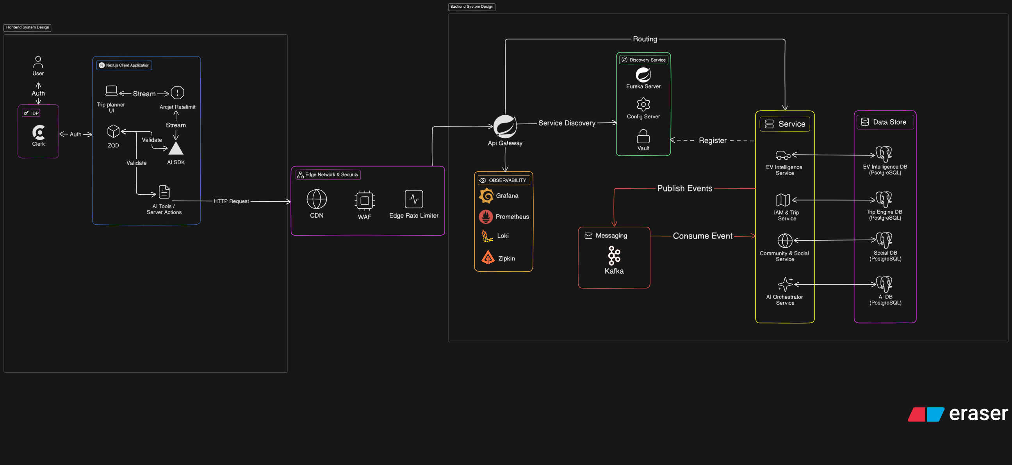
Figure 3.2: Shows Frontend & Backend System Design
Figure 3.2 illustrates the overall architecture of NAVIO, which adopts a microservices-based architecture to improve scalability, maintainability, and reliability. The system is divided into several layers, including the frontend layer, security layer, backend services layer, data storage layer, and monitoring layer.
Frontend Layer:
The frontend is developed using Next.js and provides the main interface for trip planning, EV charger discovery, community interaction, and AI-assisted travel planning. Clerk handles user authentication and session management, while Zod validates user input before requests are processed. The AI SDK enables communication with AI services for itinerary generation and travel recommendations.
Edge Network & Security Layer:
All incoming requests pass through a security layer consisting of a CDN, Web Application Firewall (WAF), and Edge Rate Limiter. These components improve application performance while protecting the system from malicious requests and abuse.
Backend Services Layer:
The backend utilizes an API Gateway as the central entry point for client requests. Service discovery and configuration management are handled by Eureka Server, Config Server, and Vault.
The system consists of four core services:
- IAM & Trip Service – Manages user authentication, authorization, user profiles, trip creation, itinerary planning, trip collaboration, budget management, and trip-sharing functionalities.
- EV Intelligence Service – Handles charging station information, EV routing, charging recommendations, charger reviews, and EV travel intelligence.
- Community & Social Service – Manages community discussions, shared travel plans, social interactions, comments, and notifications generated from community activities and system events.
- AI Orchestrator Service – Coordinates communication with AI models and provides AI-assisted itinerary generation, trip modification, and travel recommendations.
Event Communication Layer:
Apache Kafka is used for asynchronous communication between services. This event-driven approach improves scalability and reduces direct dependencies between system components.
Data Storage Layer:
Each service maintains its own PostgreSQL database to ensure data isolation and independent scalability. The system includes dedicated databases for Trip, EV, Community, and AI services.
Observability Layer:
System monitoring is supported by Prometheus, Grafana, Loki, and Zipkin, which provide metrics collection, dashboard visualization, log aggregation, and distributed tracing.
Data Storage Layer:
Each service maintains its own dedicated PostgreSQL database following the database-per-service architecture.
The system consists of:
- Trip Engine Database – Stores user information, authentication data, trips, itineraries, travel schedules, budgets, and collaboration records managed by the IAM & Trip Service.
- EV Intelligence Database – Stores charging station information, charger reviews, EV routing data, and charging recommendations managed by the EV Intelligence Service.
- Social Database – Stores community discussions, shared travel plans, comments, notifications, and social interaction records managed by the Community & Social Service.
- AI Database – Stores AI sessions, prompts, generated responses, tool invocations, and usage records managed by the AI Orchestrator Service.
This separation improves data isolation, service independence, and overall system scalability.

3.3.3 Data Flow Diagram
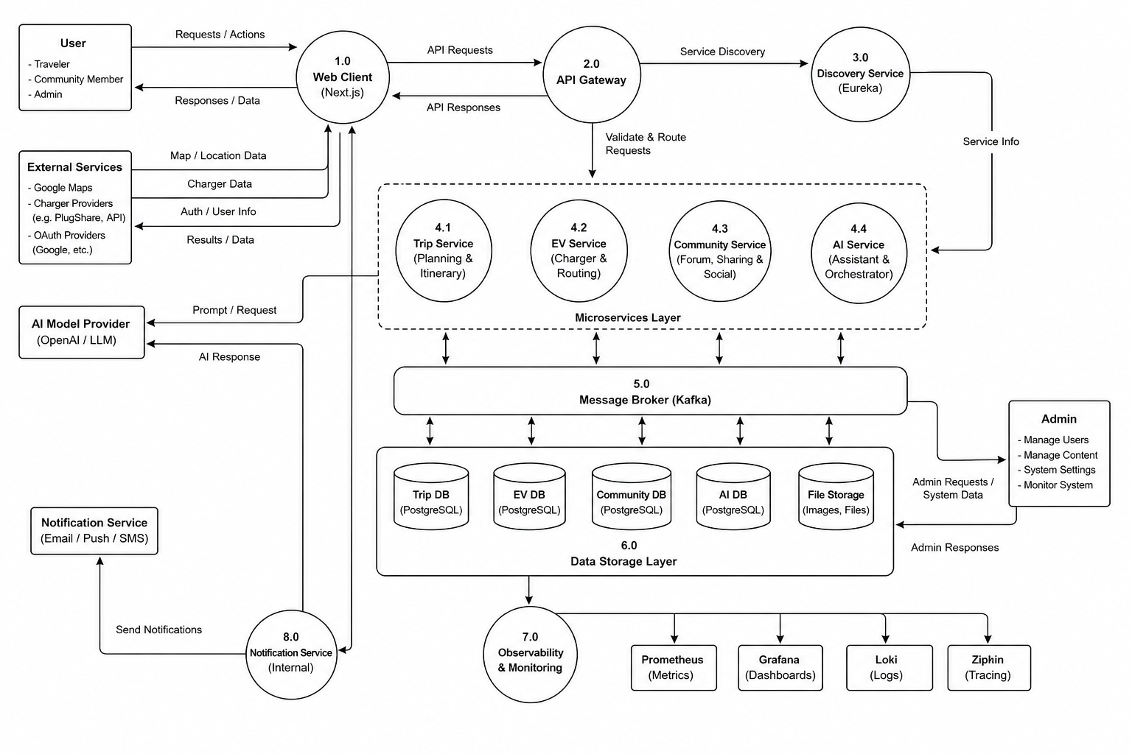
Figure 3.3: Shows Data Flor Diagram
The diagram shows how user requests are processed through the frontend application, routed to backend services, stored in dedicated databases, and returned to users. It also demonstrates the interaction between external services, AI providers, notification systems, and monitoring components.
Web Client: The data flow begins when users interact with the NAVIO web application through the Web Client. Users can create trips, manage itineraries, explore EV charging stations, participate in community discussions, and request AI-assisted travel planning. The Web Client receives user requests and forwards them to the API Gateway while displaying the returned results to users.
API Gateway and Service Discovery: The API Gateway acts as the central entry point for all requests. It validates incoming requests and routes them to the appropriate backend service. To determine the correct destination, the gateway communicates with the Discovery Service, which maintains information about all available services within the system.
Microservices Layer: Once routed, requests are processed by the corresponding microservice. The Trip Service manages trip planning and itinerary-related operations. The EV Service handles charging station information, EV routing, and charging recommendations. The Community Service manages shared plans, discussions, notifications, and social interactions. The AI Service processes AI-assisted itinerary generation and travel recommendations.
External Service Integration: Several external services provide additional data required by the platform. Authentication providers supply user authentication information, mapping services provide location and navigation data, while charging station providers supply charger information. For AI-related requests, the AI Service communicates with external AI model providers and returns generated responses to users.
Message Broker: Communication between services is supported by Apache Kafka, which acts as a message broker. Services can publish and consume events asynchronously, allowing information to be exchanged efficiently while reducing direct dependencies between system components.
Data Storage Layer: Processed information is stored within dedicated databases. Trip-related data is stored in the Trip Database, EV information is stored in the EV Database, community content is stored in the Community Database, and AI-related information is stored in the AI Database. Media files such as images and uploaded content are stored separately within the file storage system.
Notification Service: System-generated events may trigger notifications for users. The internal Notification Service processes these events and forwards notification requests to external providers, which deliver notifications through email, push notifications, or SMS channels.
Observability and Monitoring: Operational data generated by the system is collected by the observability layer. Monitoring tools such as Prometheus, Grafana, Loki, and Zipkin gather metrics, logs, and traces to support system monitoring, performance analysis, and troubleshooting activities.

3.3.4 ER Diagram
1) Trip ER Diagram
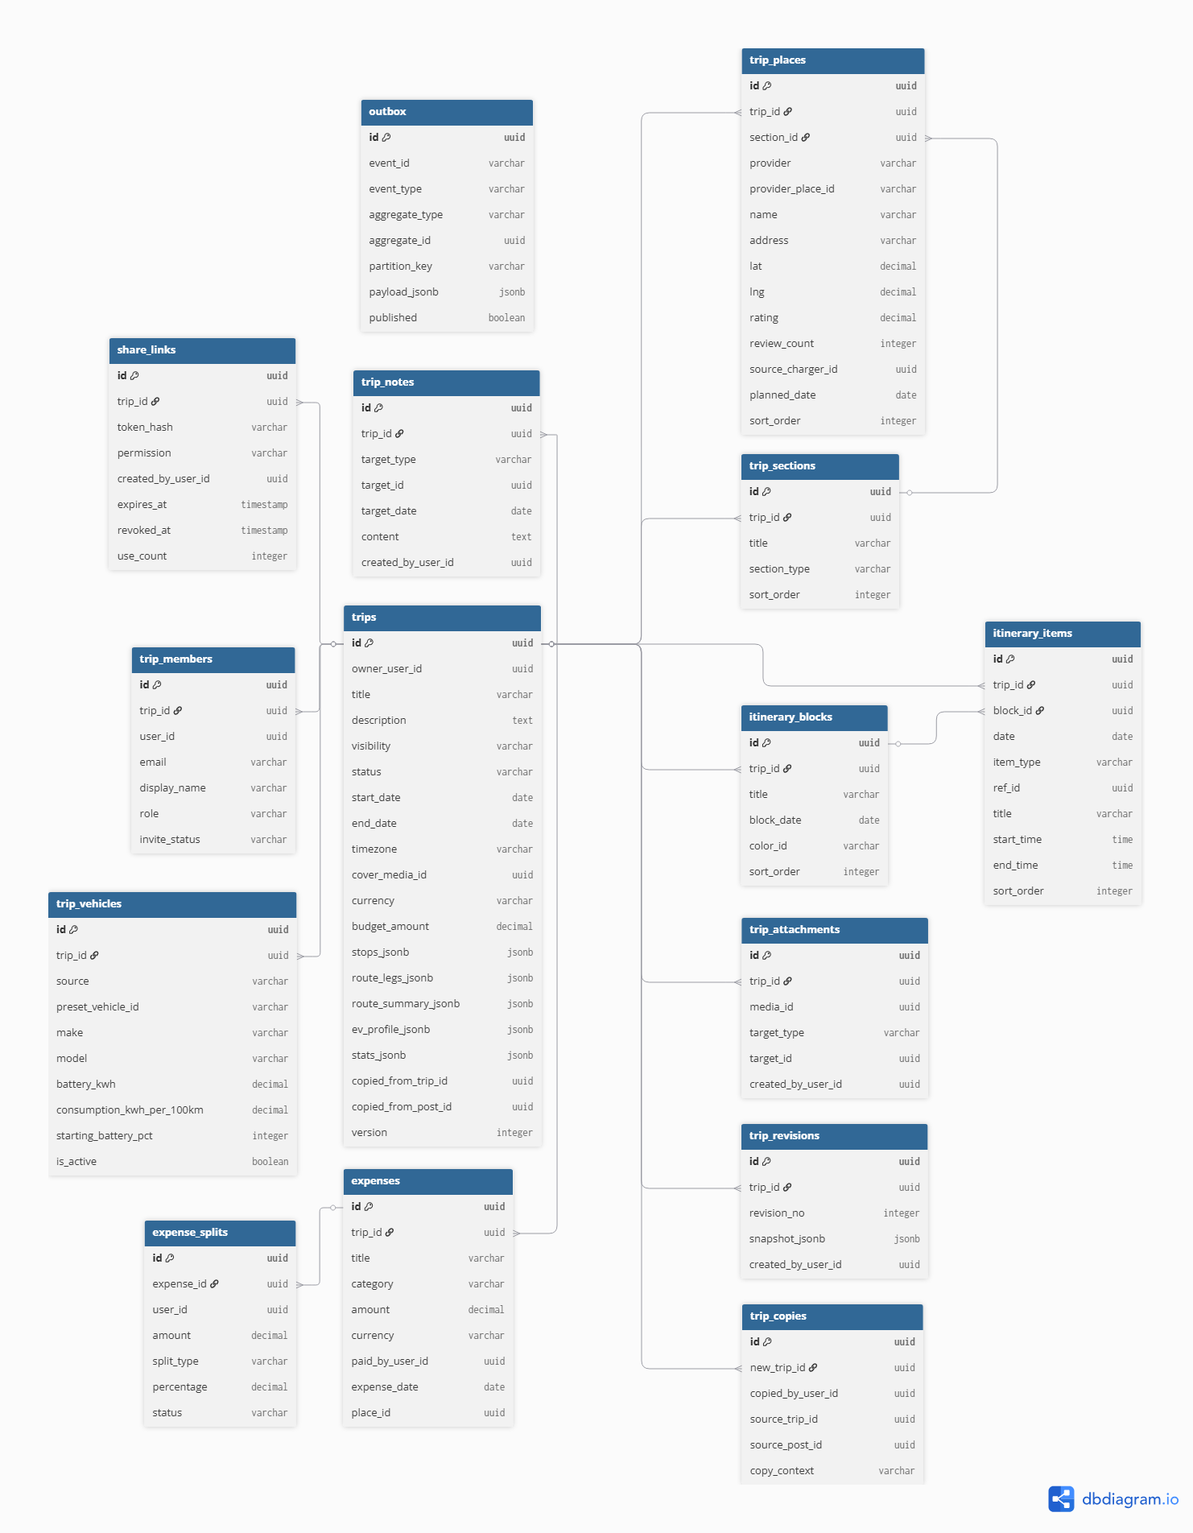
Figure 3.4: Shows Trip ER Diagram
Figure 3.4 illustrates the ER Diagram of the Trip Database, which manages trip planning, itinerary organization, collaboration, budgeting, and EV-related travel information. The database is centered around the trips table, which stores the primary information of each travel plan and acts as the parent entity for most trip-related records.
Trip Structure Management: The trip_sections, trip_places, itinerary_blocks, and itinerary_items tables are used to organize travel plans into structured itineraries. These entities allow users to arrange destinations, activities, and schedules according to specific dates and trip segments.
Vehicle Information: The trip_vehicles table stores vehicle information such as battery capacity, energy consumption rate, and starting battery level. This data supports EV route planning and charging recommendation functionalities.
Expense Management: The expenses and expense_splits tables manage trip-related expenditures and cost sharing among participants. This enables users to track budgets and distribute expenses during collaborative trips.
Collaboration and Sharing: The trip_members table stores participant information and roles, while the share_links table manages trip-sharing permissions and access control. Together, these entities support collaborative trip planning and plan sharing.
Additional Resources: The trip_notes and trip_attachments tables store supplementary information such as notes, documents, and media files associated with a trip.
Version Control and Event Processing: The trip_revisions and trip_copies tables support trip history tracking and plan duplication. In addition, the outbox table stores domain events before they are published to other services, supporting the system's event-driven architecture.
Overall, the Trip Database provides a structured foundation for managing travel plans, destinations, schedules, budgets, and collaboration features within the NAVIO platform.

2) EV ER Diagram
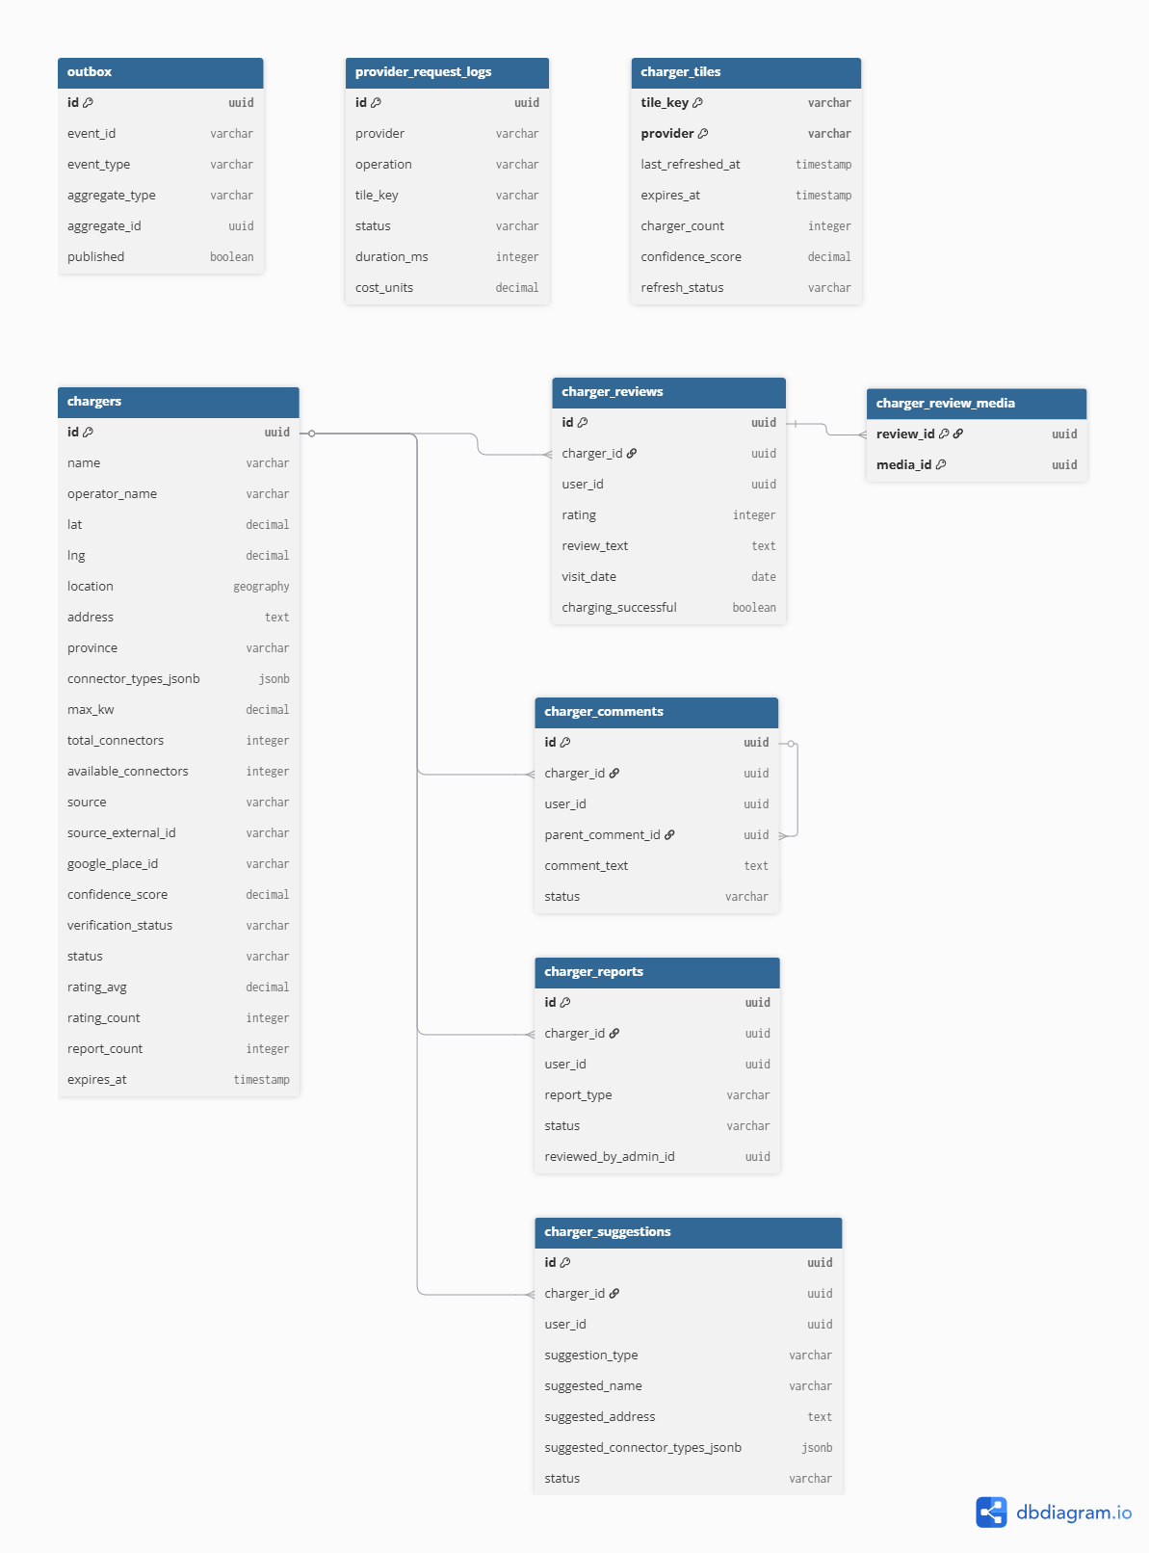
Figure 3.5: Shows EV ER Diagram

Figure 3.5 illustrates the ER Diagram of the EV Database, which manages charging station information, charger reviews, user feedback, and EV-related data used by the NAVIO platform. The database is centered around the chargers table, which stores detailed information about charging stations, including location, operator information, connector types, charging capacity, availability status, ratings, and verification records.
Charging Station Management: The chargers table serves as the primary entity of the database. It maintains charging station information collected from external providers and community contributions. Supporting tables such as charger_tiles and provider_request_logs are used to manage cached charger datasets and track data retrieval activities from external charging station providers.
Community Feedback: User-generated feedback is managed through the charger_reviews and charger_review_media tables. The charger_reviews table stores ratings, review content, and charging experiences submitted by users, while the charger_review_media table allows media files to be associated with specific reviews. These entities help improve the reliability and usefulness of charger information.
Community Interaction: The charger_comments table enables users to discuss charging stations, share experiences, and provide additional information. The table supports threaded discussions through parent-child comment relationships, allowing community members to engage in charger-related conversations.
Reporting and Suggestions: The charger_reports table allows users to report inaccurate, outdated, or problematic charger information for administrative review. Similarly, the charger_suggestions table stores user-submitted suggestions for updating charger details, including names, addresses, and connector information. These entities support continuous data improvement through community participation.
Event Processing: The outbox table supports the system's event-driven architecture by storing EV-related events before they are published to other services through the messaging infrastructure. This mechanism ensures reliable communication and synchronization between system components.
Overall, the EV Database provides a centralized repository for charging station management, community-driven feedback, and EV travel intelligence. Its structure supports accurate charger information, user participation, and continuous data maintenance within the NAVIO platform.

3) User (IAM) ER Diagram
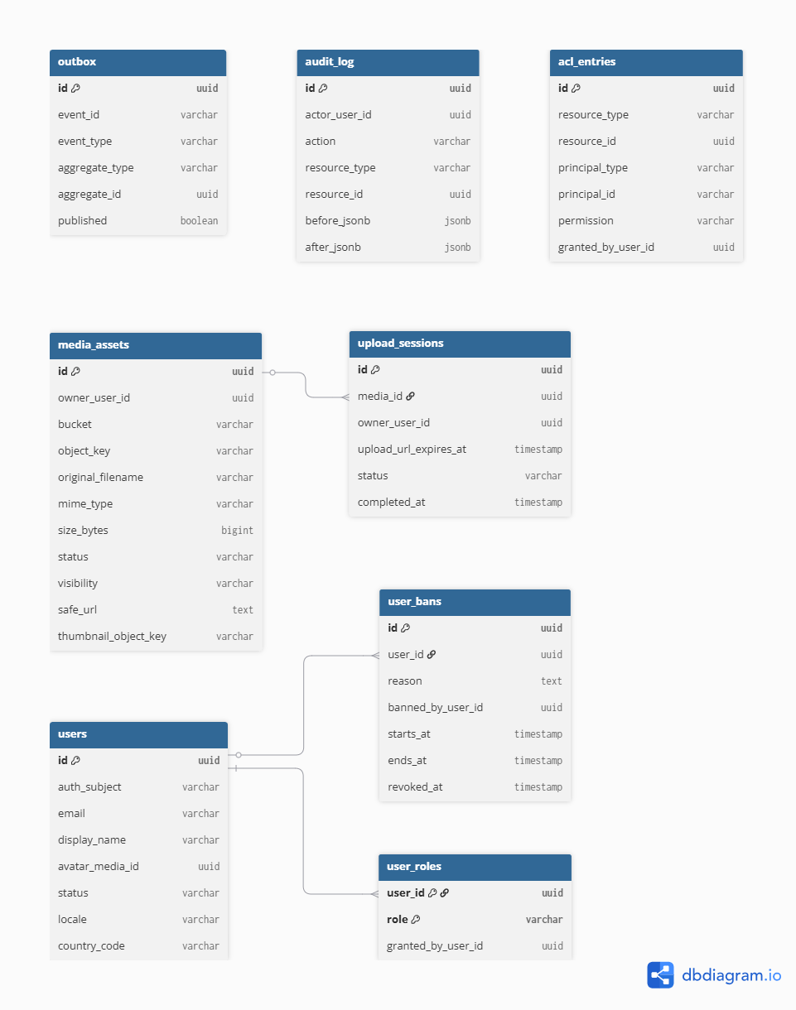
Figure 3.6: User ER Diagram
Figure 3.6 illustrates the ER Diagram of the User (IAM) Database, which manages user identities, authentication-related information, authorization controls, media assets, and administrative records within the NAVIO platform. The database serves as the foundation for access management and user account administration across all system modules.
User Management: The users table acts as the central entity of the database. It stores essential user information, including authentication identifiers, email addresses, display names, account status, locale settings, and profile media references. Most IAM-related entities are directly associated with this table.
Role and Access Control: Authorization is managed through the user_roles and acl_entries tables. The user_roles table assigns system roles to users, while the acl_entries table provides fine-grained access control by defining permissions for specific resources. Together, these entities ensure that users can only access functionalities and resources permitted by the system.
Account Moderation: The user_bans table stores records of suspended or restricted users, including ban reasons, duration, and administrative actions. This enables administrators to enforce platform policies and maintain community standards.
Media Management: User-uploaded files are managed through the media_assets and upload_sessions tables. The media_assets table stores metadata for images and other media resources, while the upload_sessions table tracks upload activities and file processing status. These entities support profile images and other media-related features across the platform.
Auditing and Event Processing: The audit_log table records significant user and administrative activities, providing accountability and traceability for system operations. In addition, the outbox table supports the event-driven architecture by storing domain events before they are published to other services, ensuring reliable communication between system components.
Overall, the User (IAM) Database provides the foundation for identity management, authorization, media handling, and administrative oversight, ensuring secure and controlled access throughout the NAVIO platform.

4) ER Diagram Notification Database
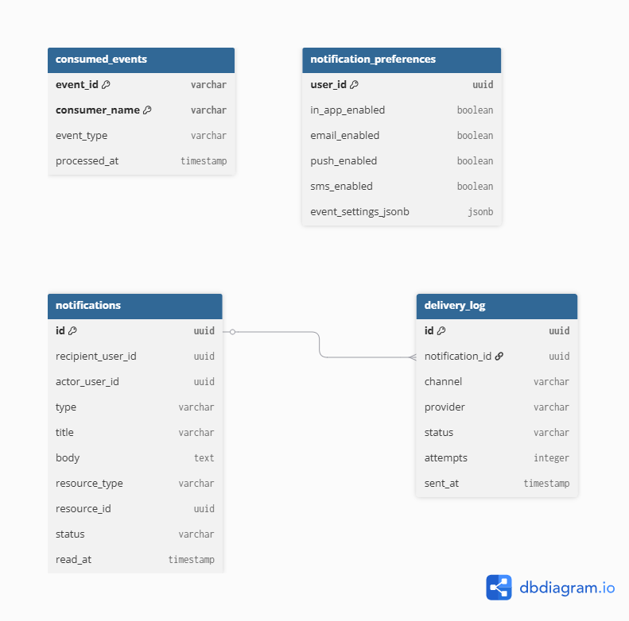
Figure 3.7: Shows Notification ER Diagram
Figure 3.7 illustrates the ER Diagram of the Notification Database, which manages user notifications, delivery tracking, notification preferences, and event consumption records within the NAVIO platform. The database ensures that users receive timely updates regarding trip activities, community interactions, system events, and other platform notifications.
Notification Management: The notifications table serves as the central entity of the database. It stores notification details such as the recipient, triggering user, notification type, content, related resources, delivery status, and read status. This table acts as the primary record for all notifications generated within the system.
Notification Preferences: The notification_preferences table stores user-specific notification settings. Users can configure their preferred notification channels, including in-app notifications, email, push notifications, and SMS. This allows the system to deliver notifications according to individual user preferences.
Delivery Tracking: The delivery_log table records notification delivery activities across different communication channels. It stores information such as the delivery provider, delivery status, number of attempts, and delivery timestamps. This enables monitoring and troubleshooting of notification delivery processes.
Event Processing: The consumed_events table supports the event-driven architecture by tracking events that have already been processed by the notification system. This prevents duplicate processing and ensures that notifications are generated reliably and consistently.
Overall, the Notification Database provides a structured mechanism for managing user notifications, delivery preferences, and event processing, ensuring effective communication between the NAVIO platform and its users.

5) Community ER Diagram
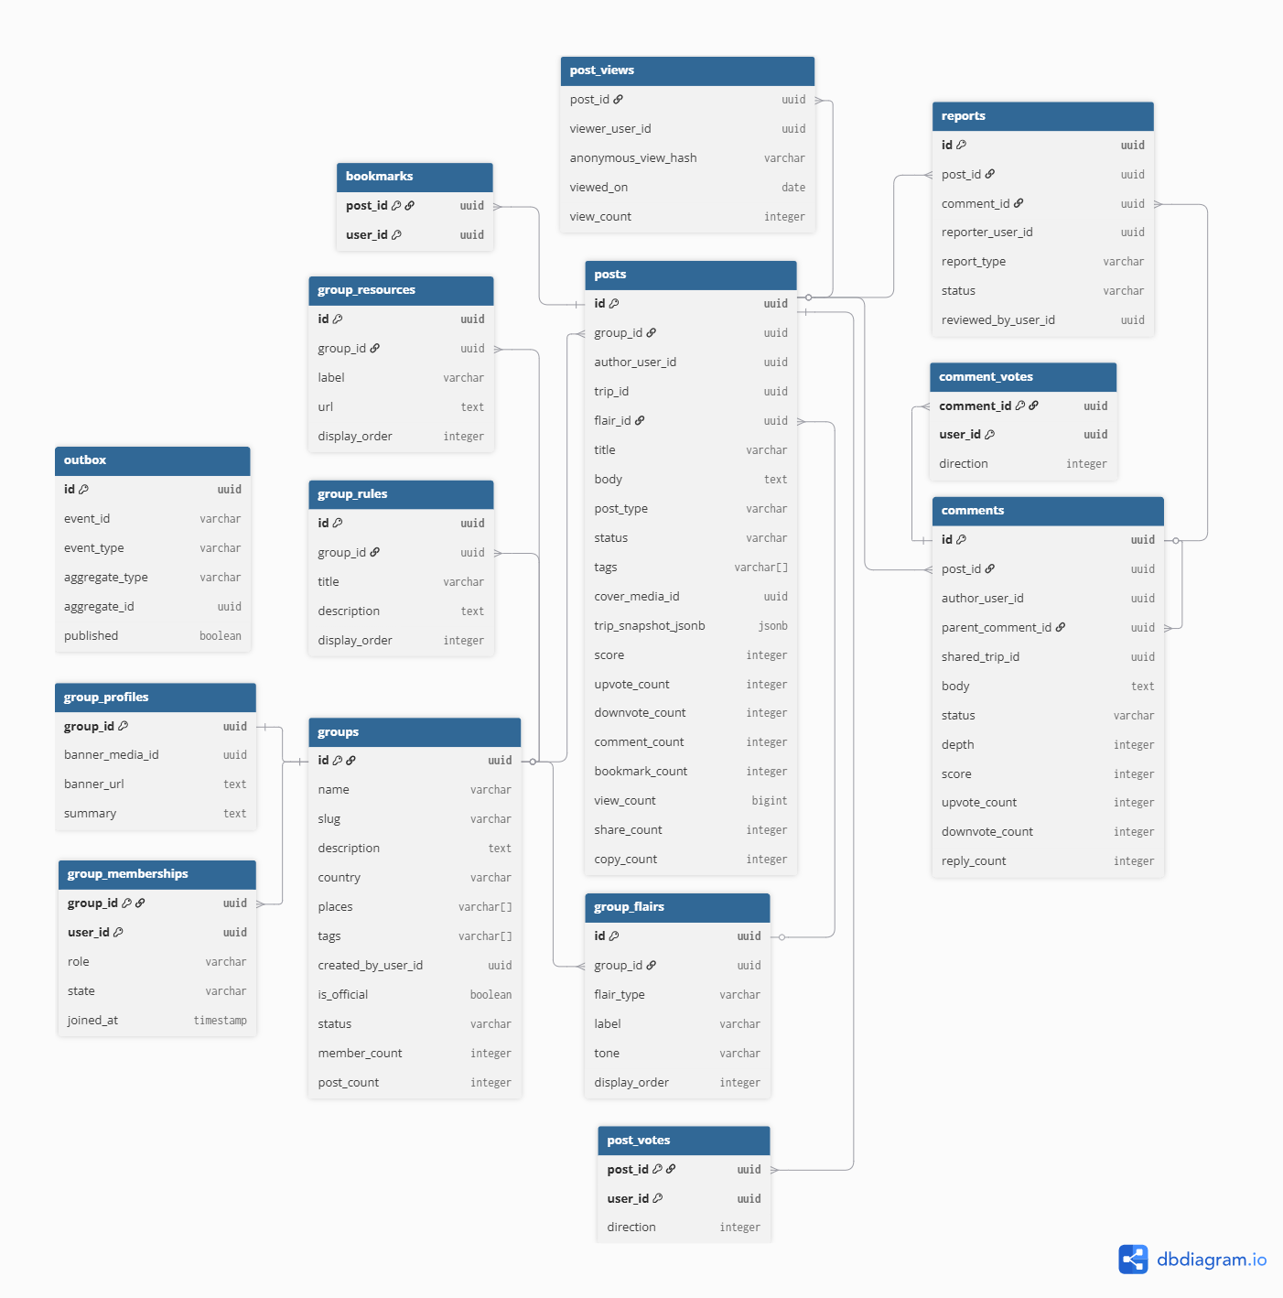
Figure 3.8: Shows Community ER Diagram

Figure 3.8 illustrates the ER Diagram of the Community Database, which manages community groups, discussion posts, user interactions, content moderation, and trip-sharing activities within the NAVIO platform. The database enables users to participate in EV-related discussions, share travel experiences, and engage with other community members.
Community Management: The groups table serves as the primary entity for organizing community spaces. Each group contains information such as its name, description, location coverage, tags, and membership statistics. Supporting entities including group_profiles, group_memberships, group_rules, group_resources, and group_flairs manage group appearance, membership records, community guidelines, shared resources, and post categorization.
Content Creation and Sharing: The posts table acts as the central entity for community content. It stores discussion posts, shared trip plans, announcements, and other user-generated content. Posts can be associated with specific groups and may reference shared trip information, allowing users to showcase and discuss travel plans within the community.
Community Interaction: User engagement is supported through the comments, post_votes, comment_votes, bookmarks, and post_views tables. These entities allow users to comment on posts, vote on content, save posts for future reference, and track content popularity through view statistics. Together, they encourage participation and content discovery within the platform.
Moderation and Reporting: The reports table supports content moderation by allowing users to report inappropriate posts or comments. Report records can be reviewed and managed by administrators to maintain community standards and ensure a safe discussion environment.
Event Processing: The outbox table supports the platform's event-driven architecture by storing community-related events before they are published to other services. This ensures reliable communication and synchronization between system components.
Overall, the Community Database provides the foundation for social interaction, trip sharing, content management, and community engagement within the NAVIO platform, enabling users to collaborate and share knowledge related to EV travel experiences.

6) AI ER Diagram
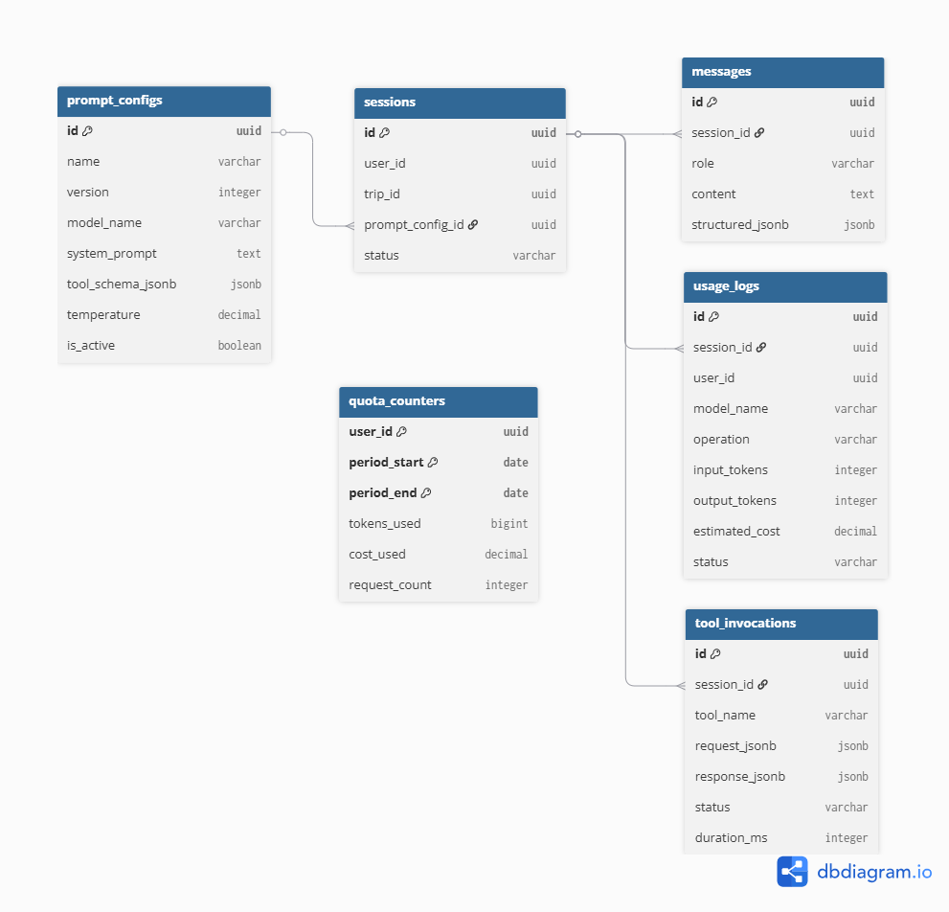

Figure 3.9: Shows AI ER Diagram

Figure X illustrates the ER Diagram of the AI Database, which manages AI conversations, prompt configurations, tool execution records, usage tracking, and resource consumption within the NAVIO platform. The database supports AI-assisted trip planning, itinerary generation, travel recommendations, and intelligent user interactions.
AI Configuration Management: The prompt_configs table stores prompt templates and model configurations used by the AI service. It contains information such as model settings, system prompts, tool schemas, and configuration versions, allowing AI behavior to be managed and updated consistently.
Session and Conversation Management: The sessions table serves as the central entity of the database and stores AI interaction sessions associated with users and trips. Each session can contain multiple conversation records stored in the messages table, which maintains the exchange between users and the AI assistant throughout a planning session.
Tool Execution Management: The tool_invocations table records tool calls performed by the AI service during conversations. It stores request data, generated responses, execution status, and processing duration, enabling the system to track AI-assisted operations and external tool usage.
Usage Monitoring: AI resource consumption is tracked through the usage_logs table. This table records model usage information such as token consumption, operation type, processing status, and estimated costs. These records support monitoring, auditing, and optimization of AI-related activities.
Quota Management: The quota_counters table maintains usage quotas for individual users within a specified period. It tracks token usage, request counts, and accumulated costs, allowing the system to enforce usage limits and ensure fair allocation of AI resources.
Overall, the AI Database provides the foundation for managing AI conversations, prompt configurations, tool integrations, and usage monitoring. Its structure enables reliable AI-assisted trip planning while maintaining operational control and resource management within the NAVIO platform.

Chapter 4 System Analysis & Design

Chapter 5 System Analysis & Design

References

Appendix

